1. To study the below Snapshot, please read the description below the snapshot.  
   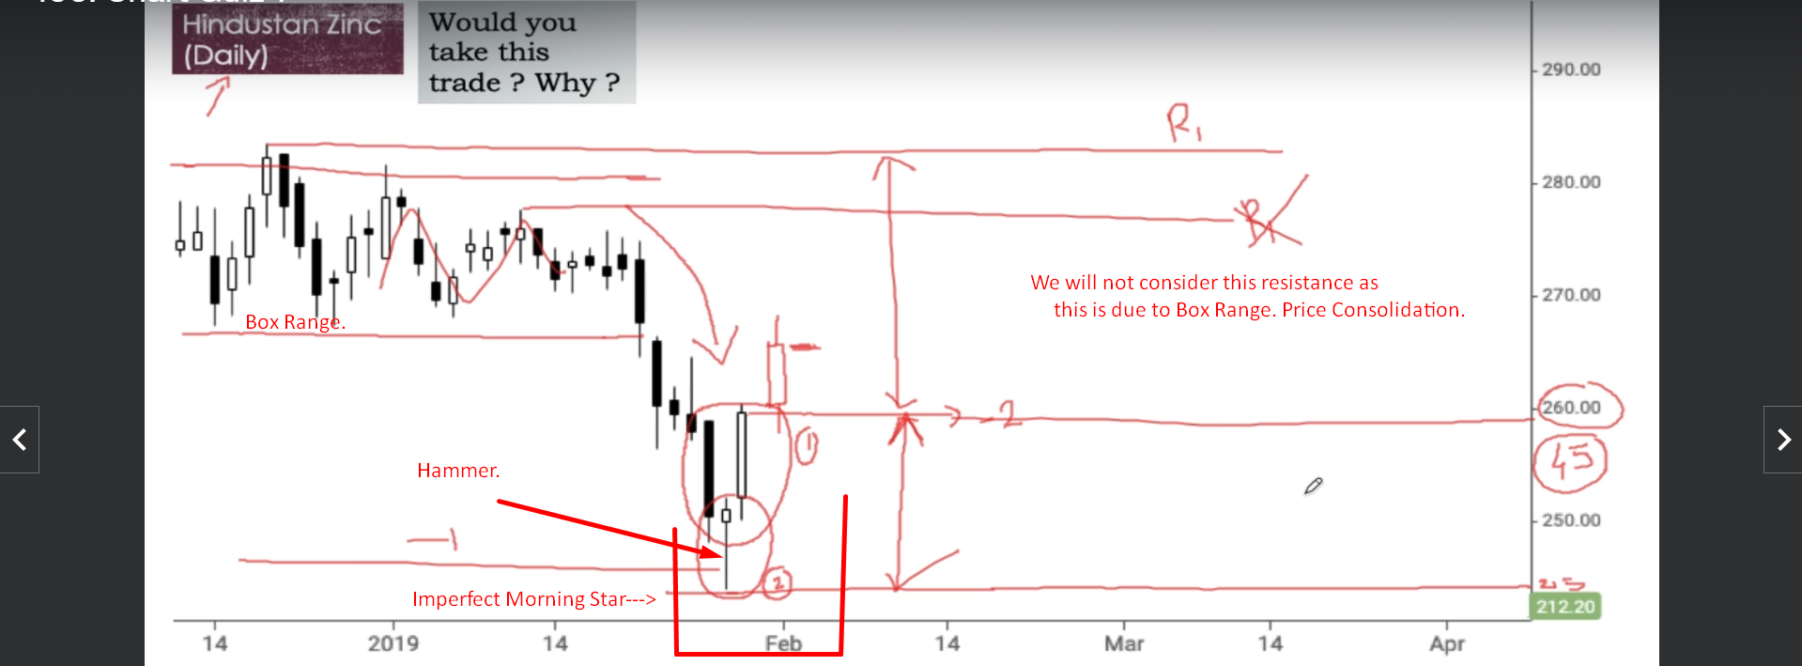
2. First this is daily chart.
3. Here you can see Price Consolidation.
4. Nice Downtrend.
5. 2nd Candle is Hammer out of 3 candles in Morning Star.
   1. Lower Shadow is twice the height of real body.
   2. It is white.
   3. The real body coming at the upper end of the **Trading Range**.
   4. Bullish Sign.
6. **Morning Start**:
   1. Not perfect as 1st two candle bodies touching each other.
   2. 3rd candle closing above the mid of 1st black candle. In fact, it is closing above the opening of 1st candle which is more powerful.
7. So, two Positive Signs
   1. Hammer.
   2. Imperfect Morning Star.
8. Problems:
   1. No Prior Support Confirmation.
   2. Reward to Risk is not 2 to 1 but slightly less whereas Risk in itself is very huge.
9. **NOTE**: We are just analyzing the trade just looking at Candlestick patterns without using any indicators to decide if we should take the trade or not.
10. If we wait for price confirmation, then the Risk will increase and reward will reduce because we have to make our entry on higher price then.
11. 